**Program no____2_____**

**Program Title_____Traffic Light____________**

**Aim Three colours will blink according to the delay given**

**Hardware Required**

* Arduino Board
* 3 LED lights

**Circuit Diagram**

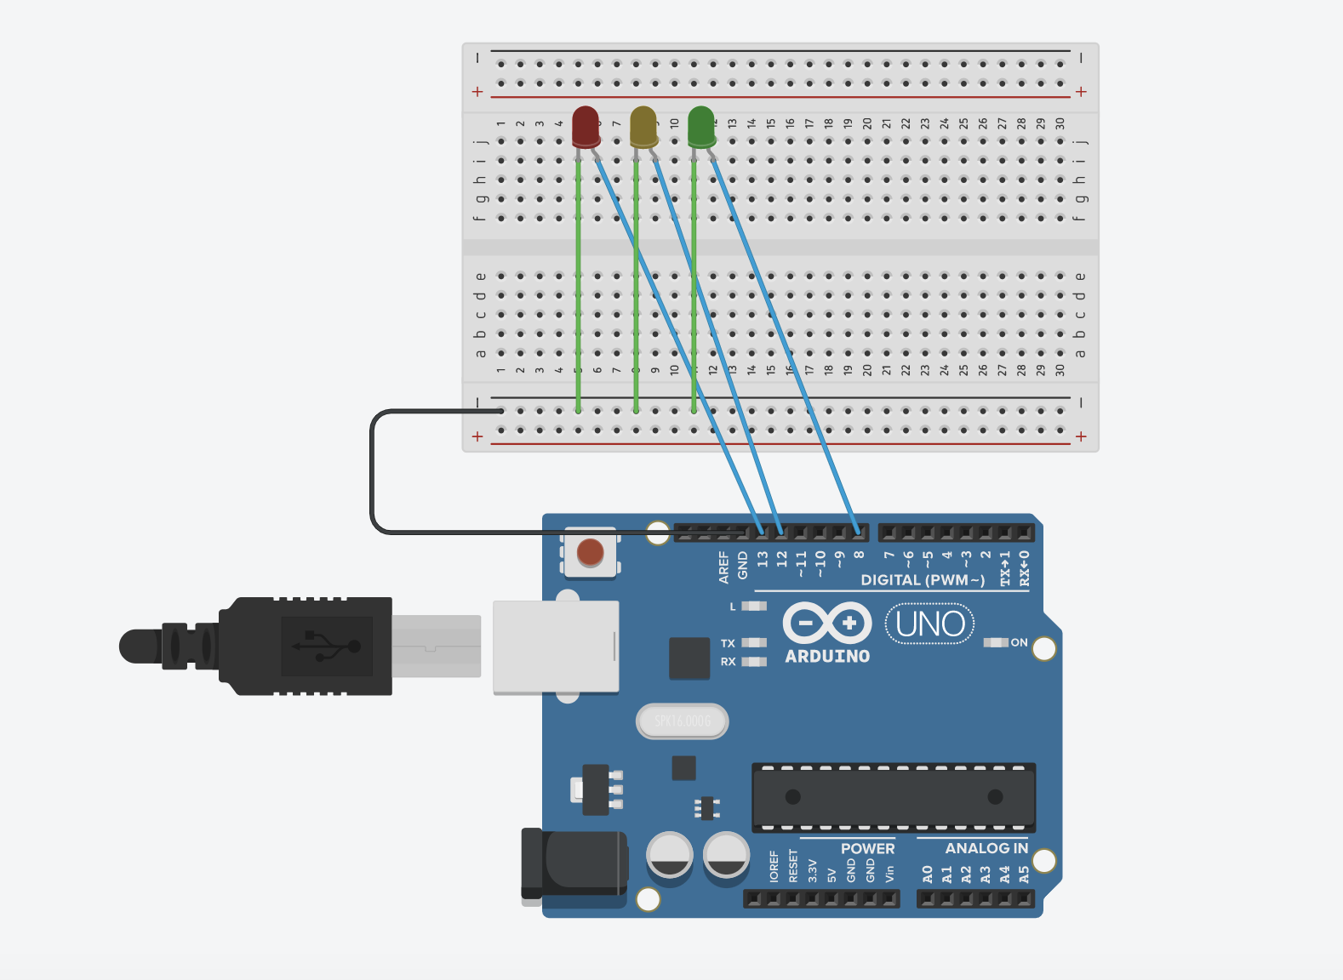

**Code:**

**void setup() {**

**// put your setup code here, to run once:**

**pinMode(13,OUTPUT);**

**pinMode(12,OUTPUT);**

**pinMode(8,OUTPUT);**

**}**

**void red(){**

**digitalWrite(13,HIGH);**

**digitalWrite(12,LOW);**

**digitalWrite(8,LOW);**

**}**

**void yellow(){**

**digitalWrite(13,LOW);**

**digitalWrite(12,HIGH);**

**digitalWrite(8,LOW);**

**}**

**void green(){**

**digitalWrite(13,LOW);**

**digitalWrite(12,LOW);**

**digitalWrite(8,HIGH);**

**}**

**void loop() {**

**// put your main code here, to run repeatedly:**

**red();**

**delay(3000);**

**yellow();**

**delay(2000);**

**green();**

**delay(3000);**

**yellow();**

**delay(2000);**

**}**

**Observation /Output**

**Three lights will Blink with 2-3 second delay.**